Necklace Pen Instructions

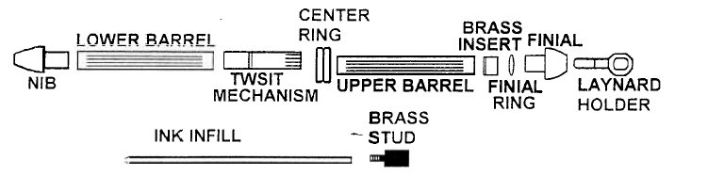

- Cut wood / material to roughly ¼” longer than the length of the brass tube. This extra ¼” reduces the possibility of losing the blank due to break out when the drill bit exits the bottom of the blank.
- Drill through the blank using a 7mm drill bit.
- Glue the two brass tubes into the prepared blanks and leave to set.
- Cut the blanks back to slightly longer than the brass tube.
- Sand (or use a barrel trimmer) to clean and trim the end of the blank back to the brass tube.
- Turn the blanks down to the size of the centre ring, nib and gold finial ring or to the bushings diameter.
- Sand and finish.
- Press the top into the end of one of the brass tubes.
- Insert the twist mechanism into the other end of this brass tube. Press in until the brass tube just covers up to 1/8” of the indentation mark on the mechanism. (Inserting the cartridge to see if the point protrudes through the top by a suitable amount may check this).
- Slide the centre ring over the mechanism.
- Press the brass stud into the remaining brass tube and glue to secure.
- Slide the finial ring over the black finial cap.
- Press this assembly into the end of the brass stud.
- Thread the lanyard through the hole in the bail and press this into the black finial.
- Insert the ink refill into the twist mechanism and connect the two pen halves, lining up the grain if appropriate.

